**Excel Assignment - 9**

1. **What are the different margins options and do we adjust the margins of the excel worksheet?**

Excel has only two sets of built-in margin styles in addition to the default or normal style.

The process of adjusting the margin let us learn about the margin options available in Excel. They are as follows:

**Normal**: The normal margin setup is the default margin that Excel follows for each Excel sheet and its pages. It uses the standard top, bottom, left, and right margins of 3/4 inch, where 1/4 inch separates the header and footer from the top and bottom margins, respectively.

Despite the default margin, Excel allows us to choose from two other margin settings, namely Wide and Narrow.

**Wide**: The Wide margin settings that Excel applies to selected sheet uses the standard top, bottom, left, and right margins of 1- inch, where 1/2 inch separates the header and footer from the top and bottom margins, respectively.

**Narrow**: The Narrow margin settings that Excel applies to the selected sheet uses the standard top and bottom margins of 3/4 inch, left and right margins of 1/4 inch, where 0.3 inch separates the header and footer from the top and bottom margins, respectively.

**Custom**: Custom margin adjustments help us to improve the appearance of the worksheet to our liking.

**2. Set a background for your table created.**

**Step 1:** Open a new [Microsoft Excel](https://www.javatpoint.com/excel-tutorial) document **(File -> New -> Blank document -> Create**) or an existing Microsoft Excel document **(File -> Open -> Browse document location -> Open button)** in which you wish to add the background.

**Step 2:** Click on the **Page Layout tab** on the ribbon. Click on the **Background** next to the Breaks option in the **Page Setup** section. See the screenshot given below.

**Step 3:** A small **Sheet Background dialog box** will appear on the spreadsheet. **Browse the Background image** that you want to set and click on the **Insert** button at the bottom of the dialog box, as shown in the below screenshot.

**3. What are freeze panes and why do we use freeze panes? Give examples.**

Excel has a **freeze pane** feature to freeze the part of the Excel worksheet. It is used to freeze the row and column. When the Excel worksheet is large, freeze pane is a useful option to freeze the particular part of the worksheet and make the other part scrollable.

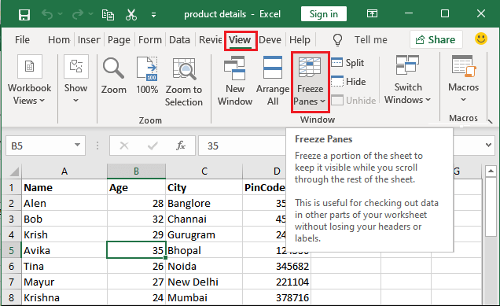

1. **What are the different features available within the Freeze Panes command?**

Excel enables three methods to freeze the pane.

1. Freeze Pane
2. Freeze Top Row
3. Freeze First Column

**5. Explain what the different sheet options present in excel are and what they do?**

Excel sheet is one of the core elements of the workbook, there are multiple core options to perform from the Sheet Options. We can access various sheet options by using the following ways:

* Ribbon Sheet Options
* Right-click Sheet Options